THEORY QUESTIONS
1.
a)

If M = {Prime integers between 1 and 11} and N = {factors of 12}, find:
(i) M ∪ N
(ii) M ∩ N
b)

Simplify 45 ÷ 3 + 2 x 8 - 12 + 42
c)

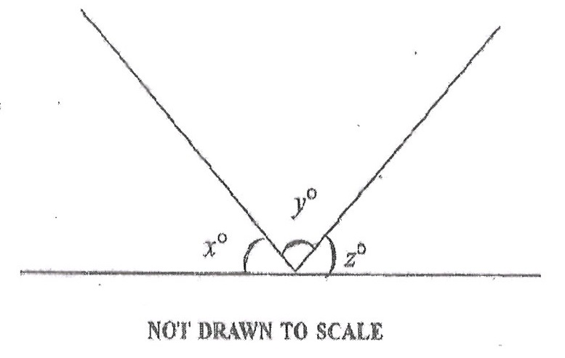
In the diagram, x, y and z are angles on a straight line. If xº : zº = 2 : 3 and y = 80º, find x.

2.
a)

Simplify: 5(6 - ab) + 2(-7 + 3ab)
b)

The equation of a straight line is given by 3x - 2y - 6 = 0. Find the:
(i) gradient of the line;
(ii) y-intercept
c)

Adwoa received a commission of 20% on bread she sold. In one week, Adwoa's commission was GH₵ 540.00.
(i) How much bread did she sell during that week?
(ii) Find her average daily commission.

3.
a)

Express

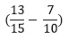

as a percentage.
b)

Factorize: ay - y - a + 1.
c)

In a fishing community of 9,400 people, the number of women exceeds the number of men by 1,500. Find the ratio of men to women in the community.

4.
a)

Solve:

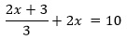
b)

Multiply 0.03858 by 0.02, leaving the answer in standard form.
c)

A cylindrical container of height 28 cm and diameter 18 cm is filled with water. The water is then poured into another container with a rectangular base of length 27 cm and width 11 cm. Calculate the depth of the water in the container. (Take π = 22⁄7)

5.
a)

If 11y = (18)²-(15)², find the value of y.
b)

Find the perimeter of a circle with radius 35 cm. (Take π = 22⁄7)
c)

Given that

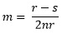
i)

make r the subject of the relation
ii)

find the value of r when s = 117, m = 2 and n = -3.

6.
a)

Copy and complete the table for the relation y = 12x - 9
x | -2 | -1 | 0 | 1 | 2 | 3 | 4 | 5
y |  |  | -9 |  |  |  | 39
i)

Using a scale of 2 cm to 1 unit on the x - axis to 10 units in the y - axis, draw on a graph sheet two perpendicular axes ox and oy.
ii)

Using the table, plot all the points of the relation y = 12x - 9 on the graph.
iii)

Draw a straight line through the points.
iv)

Use the graph to find:
(α) y when x = 2.5;
(β) x when y = 10.
b)

List the integers within the interval 7 < x ≤ 14

